Lesson 24: Piecewise and Step Functions in Context

Classwork

Opening Exercise

Here are two different parking options in the city.

|  |  |
| --- | --- |
| **1-2-3 Parking** | **Blue Line Parking** |
| $\$6$ for the first hour (or part of an hour) $\$5$ for thesecond hour (or part of an hour) $\$4$ for each hour (or part of an hour) starting with the third hour | $\$5$ per hour up to $5$ hours $\$4$ per hour after that |

The cost of a $2.75$-hour stay at 1-2-3 Parking is $\$6+\$5+\$4=\$15$. The cost of a $2.75$-hour stay at Blue Line Parking is $\$5(2.75)=\$13.75$.

Which garage costs less for a $5.25$-hour stay? Show your work to support your answer.

Mathematical Modeling Exercise

Helena works as a summer intern at the Albany International Airport. She is studying the parking rates and various parking options. Her department needs to raise parking revenues by $10\%$ to help address increased operating costs. The parking rates as of 2008 are displayed below. Your class will write piecewise linear functions to model each type of rate and then use those functions to develop a plan to increase parking revenues.

|  |  |
| --- | --- |
|  |  |

1. Write a piecewise linear function using step functions that models your group’s assigned parking rate. As in the Opening Exercise, assume that if the car is there for any part of the next time period, then that period is counted in full (i.e., $3.75$ hours is counted as $4$ hours, $3.5$ days is counted as $4$ days, etc.).

Helena collected all the parking tickets from one day during the summer to help her analyze ways to increase parking revenues and used that data to create the table shown below. The table displays the number of tickets turned in for each time and cost category at the four different parking lots.

**Parking Tickets Collected on a Summer Day at the Albany International Airport**

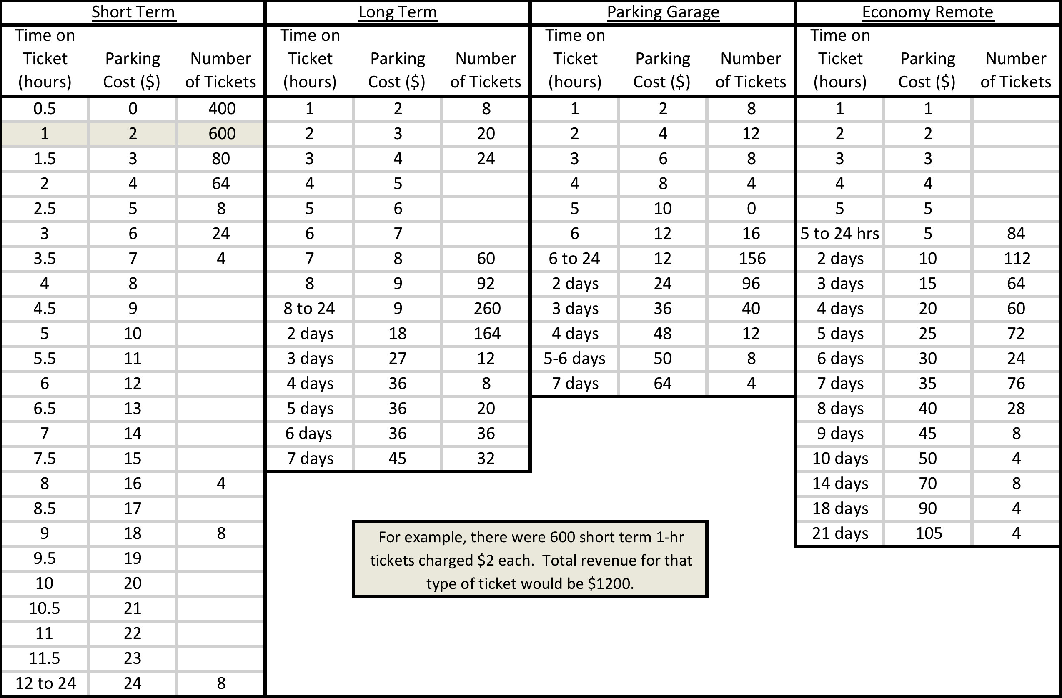

1. Compute the total revenue generated by your assigned rate using the given parking ticket data.
2. The Albany International Airport wants to increase the average daily parking revenue by $10\%$. Make a recommendation to management of one or more parking rates to change to increase daily parking revenue by $10\%$. Then, use the data Helena collected to show that revenue would increase by $10\%$ if they implement the recommended change.

Problem Set

1. Recall the parking problem from the Opening Exercise.
   1. Write a piecewise linear function $P$ using step functions that models the cost of parking at 1-2-3 Parking for $x$ hours.
   2. Write a piecewise linear function $B$ that models the cost of parking at Blue Line parking for $x$ hours.
   3. Evaluate each function at $2.75$ and $5.25$ hours. Do your answers agree with the work in the Opening Exercise? If not, refine your model.
   4. Is there a time where both models have the same parking cost? Support your reasoning with graphs and/or equations.
   5. Apply your knowledge of transformations to write a new function that would represent the result of a $\$2$ across-the-board increase in hourly rates at 1-2-3 Parking. (Hint: Draw its graph first, and then use the graph to help you determine the step functions and domains.)
2. There was no snow on the ground when it started falling at midnight at a constant rate of $1.5$ inches per hour. At 4:00 a.m., it starting falling at a constant rate of $3$ inches per hour, and then from 7:00 a.m. to 9:00 a.m., snow was falling at a constant rate of $2$ inches per hour. It stopped snowing at 9:00 a.m. (Note: This problem models snow falling by a constant rate during each time period. In reality, the snowfall rate might be very close to constant but is unlikely to be perfectly uniform throughout any given time period.)
   1. Write a piecewise linear function that models the depth of snow as a function of time since midnight.
   2. Create a graph of the function.
   3. When was the depth of the snow on the ground $8$ inches?
   4. How deep was the snow at 9:00 a.m.?
3. If you earned up to $\$113,700$ in 2013 from an employer, your social security tax rate was $6.2\%$ of your income. If you earned over $\$113,700$, you paid a fixed amount of $\$7,049.40$.
   1. Write a piecewise linear function to represent the 2013 social security taxes for incomes between $\$0$ and $\$500,000$.
   2. How much social security tax would someone who made $\$50,000$ owe?
   3. How much money would you have made if you paid $\$4,000$ in social security tax in 2013?
   4. What is the meaning of $f(150,000)$? What is the value of $f(150,000)$?
4. The function $f$ gives the cost to ship $x lb.$ via FedEx standard overnight rates to Zone 2 in 2013.
 $$f\left(x\right)=\left\{\begin{aligned}\begin{matrix}21.50 & 0<x≤1 \\ 23.00 & 1<x≤2 \\ 24.70 & 2<x≤3\end{matrix} \\ \begin{matrix}26.60 & 3<x≤4 \\ 27.05 & 4<x≤5 \\ 28.60 & 5<x≤6\end{matrix} \\ \begin{matrix}29.50 & 6<x≤7 \\ 31.00 & 7<x≤8 \\ 32.25 & 8<x≤9\end{matrix}\end{aligned}\right.$$

  1. How much would it cost to ship a $3 lb.$ package?
   2. How much would it cost to ship a $7.25 lb.$ package?
   3. What is the domain and range of $f$?
   4. Could you use the ceiling function to write this function more concisely? Explain your reasoning.
5. Use the floor or ceiling function and your knowledge of transformations to write a piecewise linear function $f$ whose graph is shown below.

